Pizza Sales Dashboard Blog

Prepared by: KOUSHIKAN . S

# Introduction

Pizza sales data is a goldmine for understanding customer preferences, busy times, and overall business performance. This dashboard provides a clear and interactive visualization of pizza sales between January 2015 and December 2015. By analyzing various KPIs and trends, we can uncover important insights about customer behavior, sales performance, and top-selling products.

# Problem Statement

# The problem faced by the pizza company was the lack of proper data insights to make informed decisions . From the data the insights found are,

* Identifying top-selling pizzas and low-performing ones.
* Understanding customer buying patterns (day-wise, month-wise).
* Recognizing the impact of pizza size and category on overall sales.
* Supporting data-driven decision-making for promotions and inventory management.

# Key Performance Indicators (KPIs)

• Total Revenue: 817.86K

• Average Order Value: 38.31

• Total Pizzas Sold: 49,574

• Total Orders: 21,350

• Average Pizzas per Order: 2.32

# Insights from the Dashboard

## 1. Busiest Days and Times

Orders are highest on Fridays and Saturdays, especially in the evenings. Monthly orders peak in July and January.

## 2. Sales Performance by Category and Size

Classic category contributes to maximum sales and total orders. Large-sized pizzas dominate sales.

## 3. Sales Trends

Sales are consistent across the week, with a spike on weekends. Sales peak in July and dip in October.

## 4. Best Sellers

• By Revenue: The Thai Chicken Pizza and Barbecue Chicken Pizza (~43K each).

• By Quantity: The Classic Deluxe Pizza (~2.5K pizzas sold).

• By Orders: The Classic Deluxe Pizza (~2.3K orders).

## 5. Worst Sellers

• By Revenue: The Brie Carre Pizza (~12K).

• By Quantity & Orders: The Brie Carre Pizza shows the lowest sales performance.

# What We Can Find from This Dashboard

• Customers prefer large-sized classic pizzas.  
• July and January are peak sales months.  
• Thai Chicken, Barbecue Chicken, and Classic Deluxe Pizzas drive the business.  
• The Brie Carre Pizza is the weakest performer.

# Visual Insights

The following visuals support the insights:

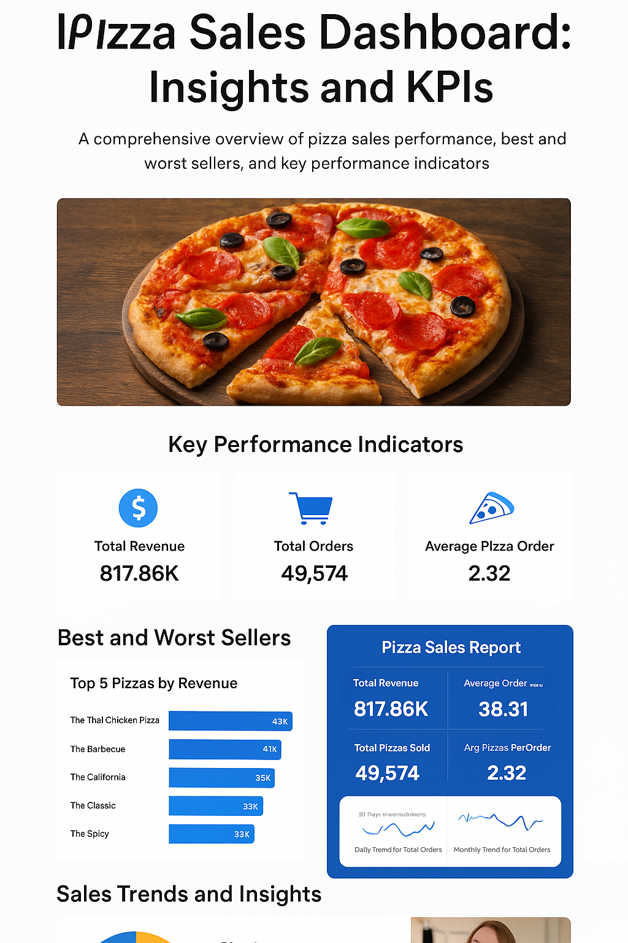

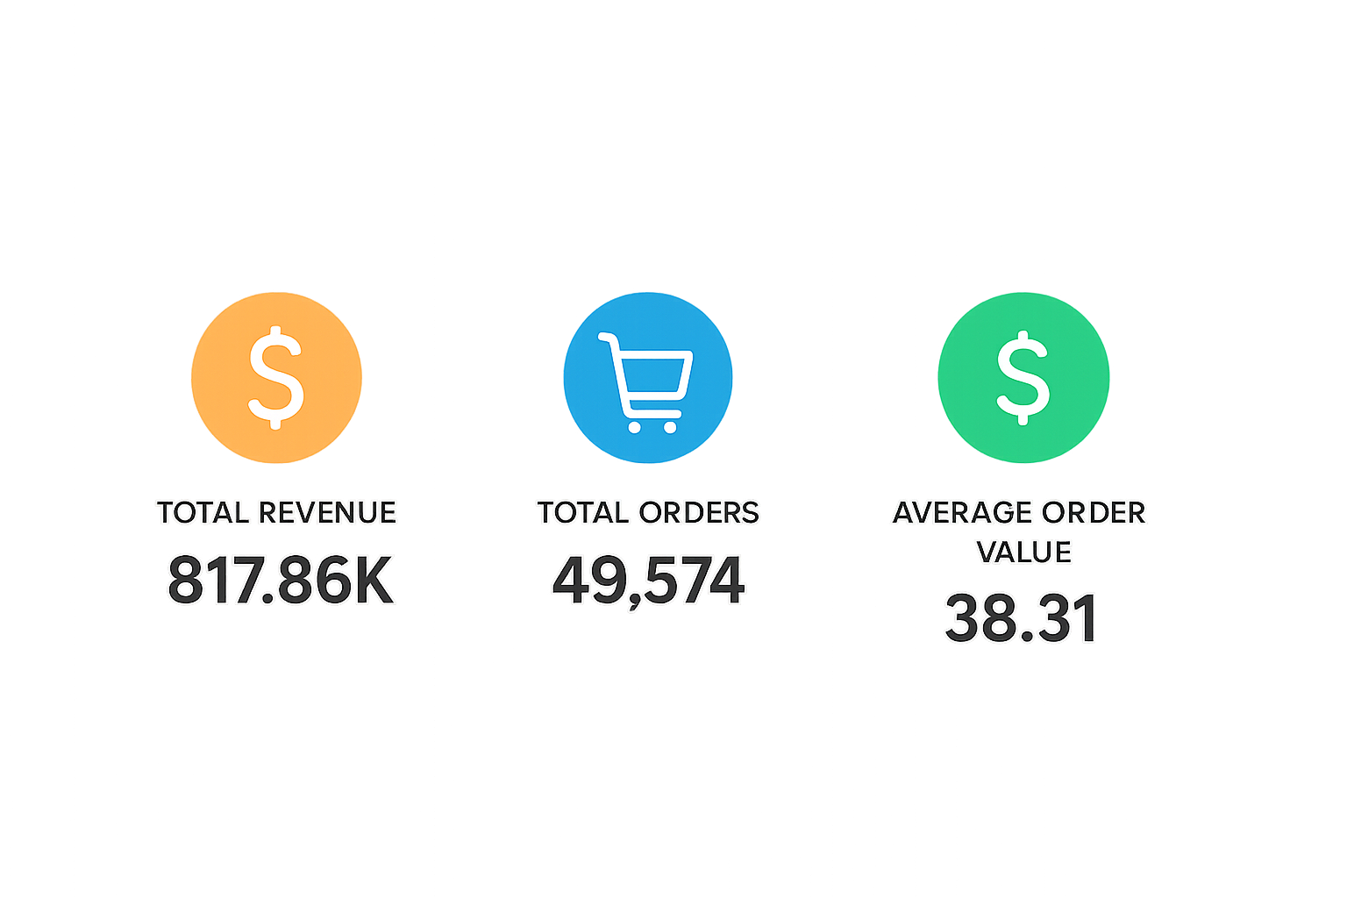

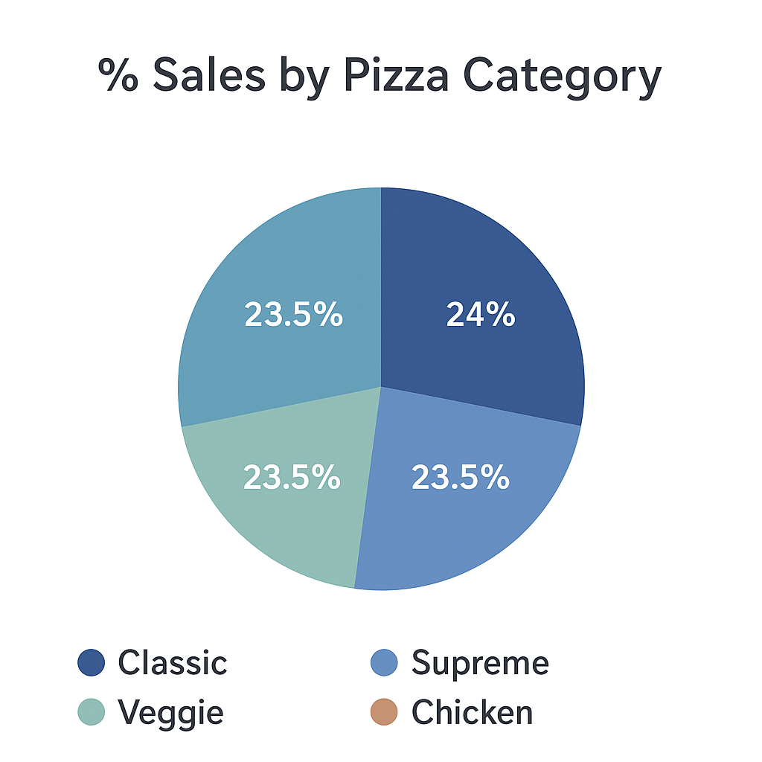

# Conclusion

This Pizza Sales Dashboard is a powerful tool for business decision-making. It helps identify customer preferences, peak sales times, and top/worst performers. With these insights, strategies can be made to improve underperforming products, boost promotions during low-sales months, and maximize revenue during peak times.